Guide

THE 90-DAY DEBT ELIMINATION PLAN
____

Debt can feel like an insurmountable obstacle, but with a structured approach and consistent action, you can systematically eliminate it while building wealth. This comprehensive 90-day plan combines the mathematical efficiency of the debt avalanche method with practical strategies for expense reduction and income optimization.
Based on the proven principles, this guide will help you create a personalized debt elimination strategy that maintains momentum through achievable milestones. Research shows that individuals who follow structured debt reduction plans are 3.2 times more likely to achieve their financial goals compared to those who take an unstructured approach.

When it comes to paying off debt, there are two primary strategies that can help you make steady progress—each with a slightly different approach depending on your priorities and goals.
First, there’s the Debt Snowball Method. This strategy involves listing your debts from the smallest balance to the largest. You focus on paying off the smallest debt first—regardless of the interest rate—while continuing to make the minimum payments on all other debts. The idea is to build momentum. Once that smallest debt is paid off, you take what you were paying on it and apply it to the next smallest debt. This method is great for motivation because you see quick wins early on.
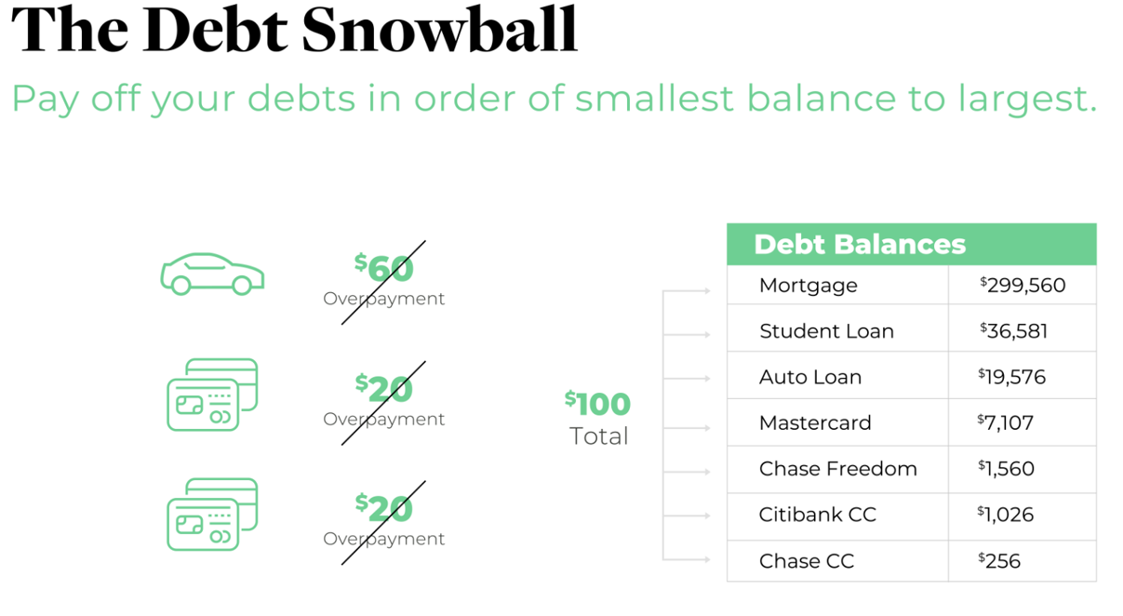
Then there’s the Debt Avalanche Method. With this approach, you prioritize your debts by interest rate—from highest to lowest. The goal here is to save the most money over time by attacking the most expensive debt first. Even if it’s a larger balance, you put any extra payments toward the debt with the highest interest rate while still making minimum payments on the others. This method is more efficient from a financial standpoint because it minimizes the total interest you’ll pay.
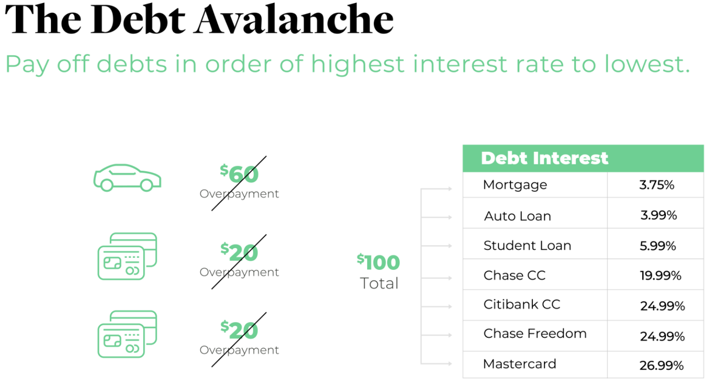

So, which method should you use?
Here’s my recommendation:
- Use the Avalanche Method for any debts with an interest rate over 6%. These are the debts that cost you the most, and paying them down first saves you the most in interest.
- For debts under 6%, such as a mortgage or some student loans, I recommend applying the Snowball Method—focusing on the smallest balances first. These lower-interest debts aren’t as urgent, so we tackle them more strategically once the higher-interest ones are handled.
The strategy I outline below is built around the Avalanche Method. When using it, it's important to track any payments you make above the minimum in your spreadsheet. This helps you see exactly where your money is going and how to most effectively redirect those extra funds to your highest-interest debts. Always make at least the minimum payment on all debts—this keeps your accounts in good standing and your credit score protected. Our aim is to aggressively target one debt at a time, without missing any payments, and gradually eliminate each one.

Traditionally, most people try to manage this using just their bank account—but what if I told you there’s a smarter, faster way to do it? There’s a strategy that can help you increase your savings, decrease your debt, and build a financial asset—often in half the time.
Curious? Let’s talk about the Debt Free Life Concept. It’s a powerful tool that’s helped many clients completely shift their financial trajectory.
📅 Book a consultation with me: www.schedulewithaudree.com
🌐 Or learn more here: www.kindsfgagency.com/debt-free

Phase 1: Foundation Building (Days 1-14)

Week 1: Financial Assessment and System Setup
Day 1-3: Complete Financial Inventory
- List all debts with their current balances and interest rates. This should include credit cards, student loans, personal loans, mortgages, auto loans, or any other Liability you have.
- Create a spreadsheet or use the Debt Tracking template that includes:
- Creditor name
- Current balance
- Interest rate
- Minimum monthly payment
- Actual payment
- Credit Utilization
- Payment due date
- Calculate your total debt burden and monthly payment obligations. This will help you calculate your debt-to-income ratio.
Day 4-7: Establish Your Debt Command Center
- Set up a dedicated debt tracking system
- Choose between spreadsheet or debt tracking app
- Input all debt information
- Calculate debt-to-income ratio
  - To calculate this, divide your total debt payments, by your total monthly income.
  - Ex: $2000 debt payments/$6500 income=0.30 or 30%
- Determine total interest paid monthly
- Calculate your credit utilization rate
  - To calculate this, take the balance of your credit card and divide it by your credit card limit. A healthy credit utilization in total should be no more than 30% of your total credit. This has a large impact on your credit score. For a debt super star, your credit utilization should be no more than 10%.
  - Ex: $2200 balance/ $5000 limit= 0.44 or 44% utilization
- Create your debt avalanche ranking
- Order debts from highest to lowest interest rate
- Calculate minimum payment requirements
- Determine available funds for extra payments or over payments you have already been used to paying out of your budget
- Set up automation for minimum payments
- Schedule automatic payments for all debts
- Align payment dates with paycheck schedule
- Create payment confirmation system

Week 2: Expense Analysis and Budget Optimization
Day 8-10: Conduct Expense Audit
- Review last 3 months of expenses
- Categorize all spending
- Identify non-essential expenses
- Look for subscription services to eliminate
- Analyze recurring bills for potential savings
Day 11-14: Create Budget Optimization Plan
- Fixed Expenses Review
- Housing costs
- Utilities
- Insurance
- Phone/Internet
- Transportation
- Variable Expenses Analysis
- Food/Groceries
- Entertainment
- Shopping
- Personal care
- Miscellaneous spending
- Identify Quick-Win Savings Opportunities
- Cancel unused subscriptions
- Negotiate bills
- Negotiate higher credit limit increase
- Negotiate lower APR on credit cards
- Switch to lower-cost alternatives
- Implement energy-saving measures

Phase 2: Acceleration Strategies (Days 15-45)

Week 3-4: Income Optimization
Day 15-21: Primary Income Enhancement
- Workplace Optimization
- Review current position for advancement opportunities
- Identify overtime possibilities
- Research internal promotion options
- Document recent achievements for salary negotiation
- Skills Enhancement Plan
- List valuable skills in your industry
- Find free or low-cost training resources
  - Udemy is a great resource!
- Create learning schedule
- Set certification goals if applicable
Day 22-28: Secondary Income Development
- Identify Side Hustle Opportunities
- Skills-based freelancing
  - Upwork is a great resource!
- Sharing economy participation
- Online platforms
  - Linked in is a great place to start!
- Local gig work
- Quick-Start Income Generators
- Selling unused items
- Online surveys and microtasks
- Cash-back apps
- Referral programs

Week 5-6: Debt Reduction Acceleration
Day 29-42: Implement Aggressive Payoff Strategies
- Apply Found Money Rules
- 100% of tax refunds to debt
- 90% of bonuses to debt
- 75% of gifts to debt
- 50% of side hustle income to debt
- Payment Optimization
- Round up all payments
- Make bi-weekly instead of monthly payments
- Apply all expense reduction savings to debt
- Use cash windfalls strategically

Phase 3: Sustainability and Growth (Days 46-90)

Week 7-9: System Refinement
Day 43-63: Fine-Tune Your Approach
- Weekly Progress Reviews
- Track debt reduction progress
- Monitor spending patterns
- Adjust budget categories as needed
- Celebrate milestone achievements
- Behavior Modification Strategies
- Use cash for variable expenses. The goal is to not let your credit card be an option. Spending on debit is also too easy. Keep cash on hand to monitor and limit your spending.
- Implement 24-hour purchase rule. Think about your purchase for 24 hours before buying something.
- Practice needs vs. wants assessment
- Build support system accountability

Week 10-13: Long-Term Success Planning
Day 64-90: Establish Lasting Changes
- Create Debt-Free Transition Plan
- Design post-debt budget
- Set up wealth-building accounts
- Plan debt payment reallocation
- Define new financial goals
- Build Financial Education Foundation
- Read one personal finance book monthly
- Join online financial communities
- Attend money management workshops
- Follow financial experts and educators

Implementation Tools and Templates

Debt Tracking Spreadsheet
Column Headers:
- Creditor Name
- Current Balance
- Interest Rate or APR
- Minimum Payment
- Actual Payment

Weekly Progress Tracker
Monitor:
- Total Debt Reduction
- Extra Payments Made
- Expenses Reduced
- Additional Income Generated
- Challenges Encountered
- Solutions Implemented

Monthly Milestone Checklist
- Debt Reduction Target Met
- Expense Reduction Goals Achieved
- Income Increase Secured
- New Skills Developed
- Systems Optimized
- Habits Strengthened

Overcoming Common Challenges

Challenge 1: Unexpected Expenses
Solutions:
- Build mini emergency fund first
  - This should be at least $2,000 in a high yield savings account as quickly as possible. All while still trying to pay off your first debt.
  - Once your debt is paid off, the goal is then to have a 3-6 month of expenses emergency fund.
  - Then once you have an emergency fund, the goal is to maximize retirement savings.
- Create expense buffer in budget
- Develop backup income sources
- Maintain strict priorities list

Challenge 2: Motivation Maintenance
Strategies:
- Track visual progress daily. Make a visual tracker! Maybe for every $100 or $1000 of debt you pay off you get a star on your chart! Visual rewards keep you going!
- Share goals with accountability partner
- Celebrate small wins, like paying off each small debt!
- Focus on debt-free vision. What will having a Debt Free Life look like to you? What will it bring you?

Challenge 3: Income Plateaus
Approaches:
- Diversify income streams
- Upgrade valuable skills
- Network strategically. Ask for opportunities within your close family or friends.
- Seek advancement opportunities within your current career or look for a new job opportunity with a new company.

Action Plan Summary

Immediate Actions (Next 24 Hours):
- Complete debt inventory
- Set up tracking system
- Calculate accelerated payoff schedule
- Identify three quick-win savings opportunities
- Schedule all minimum payments

Week One Priorities:
- Conduct full expense audit
- Create optimization budget
- Research side hustle options
- Set up progress tracking tools
- Share plan with accountability partner

First Month Goals:
- Implement all identified savings
- Launch one income-generating activity
- Make first extra debt payment
- Complete initial skills assessment
- Establish weekly review routine
Final Words

Conclusion
____

This 90-day debt elimination plan provides a structured approach to achieving financial freedom. Success requires consistent action, regular monitoring, and unwavering commitment to your goals. Remember that every dollar of debt eliminated represents a step toward financial independence.
Your journey to becoming debt-free starts now. Take the first step by completing your debt inventory and setting up your tracking system within the next 24 hours. The sooner you begin, the closer you'll be to financial freedom.
Small, consistent actions compound over time to create significant results. Stay focused on your progress, celebrate your victories, have an accountability partner and maintain unwavering commitment to your debt-free future. Your financial freedom awaits: take action today to claim it.

